**REVIEW TEST 6 *38/40***

**VOCABULARY**

**Questions 1-10.** Complete the sentences below using verbs given in the box. Change the verb form if needed.

|  |
| --- |
| buy go (x2) book put  build stay try go on pack |

1. We're going to __go__on___ a cruise for our vacation.
2. During our trip, we'll _____stay__ in a hotel by the beach.
3. The kids love to __build_____ sandcastles in the sand.
4. We plan to ____go___ sightseeing and explore the city.
5. I need to ____book___ a flight ticket for our upcoming trip.
6. I always like to ____try___ local food when I travel.
7. Don't forget to ____put___ on sunscreen to protect your skin.
8. I enjoy ___go__going__ sunbathing at the seaside.
9. Let's ____pack___ a bag with our clothes and essentials.
10. We should ____buy___ souvenirs to remember our holiday.

**Questions 11-18.** Match the words with pictures.

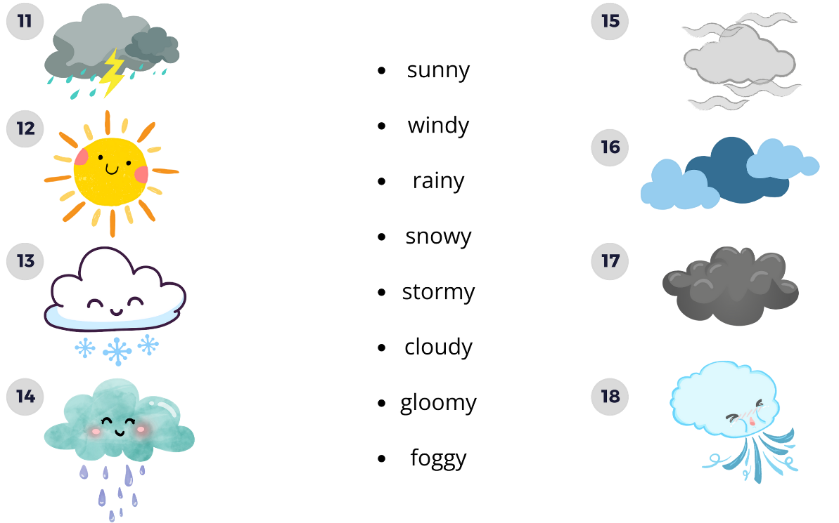

**Sunny – 12**

**Windy – 18**

**Rainy – 14**

**Snowy – 13**

**Stormy – 11**

**Cloudy – 16**

**Gloomy – 17**

**Foggy - 15**

**Questions 19-25.** Fill in the blanks with the correct jobs: *flight attendant, vet, salesperson, cashier, receptionist, taxi driver, actor.*

1. When your pet is sick, you take them to a ___vet____.
2. At the grocery store, you pay for your items at the ___cashier____.
3. When you check into a hotel, you talk to the __receptionist_____ at the front desk.
4. To get a ride in a cab, you call a ___taxi_driver___.
5. At the store, the person who helps you choose products and answers questions is the ___salesperson____.
6. In movies and on stage, people who perform are called _actor______.
7. This person helps passengers on airplanes and serves refreshments: ___flight_attendant___.

**GRAMMAR**

**Questions 26-35.** Write the correct form of verbs in the brackets to complete the sentences below.

1. They (visit) __will_visit____ the zoo next Saturday.
2. Last summer, we (go) ___went____ to the beach for a week.
3. I (work) __will_work____ late tonight to finish a project.
4. The weather (be) ___is___was_ sunny and warm during our trip.
5. She (visit) ___visited____ the museum on her last vacation.
6. It (rain) ___rained____ heavily all day yesterday.
7. She (start) __will_start____ a new job next month.
8. I (work) ___worked____ as a lifeguard at the pool last year.
9. Next summer, we (go) ___will_go___ to the mountains for our vacation.
10. The weather forecast says it (be) _will_be_____ sunny tomorrow.

**PRONUNCIATION**

**Questions 36-40.**  Choose the word which is pronounced differently from the others.

1. a) get b) general c) village
2. a) June b) give c) vegetable
3. a) this b) leather c) South
4. a) weather b) mother c) bath
5. a) cold b) come c) circle